Section A: Concept Application

1. You identify 'Attrition' as the target variable in the IBM HR dataset. What is the difference between a feature and a label in a supervised learning problem?

Answer:
In Supervised Learning, a dataset consists of features (input variables) and a label (target variable).
- Features are the input variables that help the model make predictions.
- Label is the output or target variable that the model is trained to predict.
In the IBM HR Employee Attrition dataset:
- Label (Target Variable):
  - Attrition
  - Values: Yes or No
  - It indicates whether an employee has left the company.
- Features (Input Variables):
  - Age
  - MonthlyIncome
  - JobRole
  - Department
  - DistanceFromHome
  - Education
  - YearsAtCompany
  - JobSatisfaction
  - Overtime
  - EnvironmentSatisfaction
  - etc.

Example:
Age | MonthlyIncome | Overtime | JobRole | Attrition
28 | 4000 | Yes | Sales Executive | Yes
35 | 6500 | No | Manager | No
Here,
- Features = Age, MonthlyIncome, Overtime, JobRole
- Label = Attrition
In simple words:
- Features = Information given to the model.
- Label = Answer the model has to predict.

2. The HR attrition problem predicts a Yes or No outcome. What type of ML problem is this — regression or classification?

Answer:
This is a Classification problem.

Reason:
Classification is used when the target variable contains categories or classes.
The target variable Attrition has only two possible values:
- Yes
- No
Since the model predicts which category an employee belongs to, it is a Binary Classification Problem.

Difference:
Classification | Regression
Predicts categories | Predicts numerical values
Example: Yes/No | Example: Salary, House Price
Output is a class | Output is a continuous number

Example:
Employee Data → Predict Attrition
Output:
- Yes
- No
Therefore,
ML Problem = Binary Classification

3. Your model performs well on training data but poorly on unseen test data. What is this condition called, and what causes it?

Answer:
This condition is called Overfitting.

Definition:
Overfitting occurs when a machine learning model learns the training data too well, including its noise and unnecessary details.
As a result:
- Training Accuracy → Very High
- Test Accuracy → Low
The model memorizes the training data instead of learning general patterns.

Causes of Overfitting:
- Model is too complex.
- Training dataset is too small.
- Too many features.
- Training for too many iterations (epochs).
- Presence of noise in the data.

Example:
Training Accuracy = 99%
Testing Accuracy = 72%
This indicates the model has overfitted the training data.

How to Reduce Overfitting:
- Use more training data.
- Apply Cross Validation.
- Perform Feature Selection.
- Use Regularization.
- Prune Decision Trees.
- Use simpler models.
- Apply Early Stopping (for neural networks).

4. The ML workflow follows a fixed sequence of stages. List the stages of the ML workflow in order.

Answer:
A typical Machine Learning workflow consists of the following stages:
- Problem Statement
  - Define the business problem.
- Data Collection
  - Gather relevant data.
- Data Cleaning (Preprocessing)
  - Handle missing values, duplicates, and incorrect data.
- Exploratory Data Analysis (EDA)
  - Understand the dataset using statistics and visualizations.
- Feature Engineering
  - Create, transform, or select useful features.
- Train-Test Split
  - Divide the dataset into training and testing sets.
- Model Selection
  - Choose an appropriate machine learning algorithm.
- Model Training
  - Train the model using the training dataset.
- Model Evaluation
  - Evaluate performance using metrics such as Accuracy, Precision, Recall, F1-Score, or ROC-AUC.
- Hyperparameter Tuning
  - Optimize model parameters for better performance.
- Model Deployment
  - Deploy the trained model to a production environment.
- Monitoring and Maintenance
  - Continuously monitor the model and retrain it when necessary.

Workflow Summary:
Problem Statement → Data Collection → Data Cleaning → EDA → Feature Engineering → Train-Test Split → Model Selection → Model Training → Model Evaluation → Hyperparameter Tuning → Model Deployment → Monitoring

5. You keep a separate test set that the model never sees during training. What is the purpose of this test set?

Answer:
The purpose of the test set is to evaluate how well the trained model performs on new, unseen data.
The test set is never used during training, ensuring an unbiased assessment of the model's performance.

Why is the Test Set Important?
- Measures the model's real-world performance.
- Detects overfitting.
- Provides an unbiased evaluation.
- Helps compare different models.

Example:
Suppose the dataset contains 1,470 employee records.
A common split is:
- Training Set = 80% (1,176 records)
- Test Set = 20% (294 records)
The model is trained only on the training set.
After training, predictions are made on the test set to calculate metrics such as:
- Accuracy
- Precision
- Recall
- F1-Score

Section B: Practical Task

1. Create a comprehensive Data Dictionary mapping all 35 IBM HR features to their respective statistical data types.
Target Variable: Attrition
No. | Feature Name | Description | Statistical Data Type
1 | Age | Employee Age | Numerical (Integer)
2 | Attrition | Employee Left Company (Yes/No) | Categorical (Binary) Target
3 | BusinessTravel | Travel Frequency | Categorical (Nominal)
4 | DailyRate | Daily Salary Rate | Numerical (Integer)
5 | Department | Department Name | Categorical (Nominal)
6 | DistanceFromHome | Distance from Home | Numerical (Integer)
7 | Education | Education Level (1–5) | Ordinal
8 | EducationField | Field of Education | Categorical (Nominal)
9 | EmployeeCount | Constant Value (=1) | Numerical (Integer)
10 | EmployeeNumber | Employee ID | Identifier (Nominal)
11 | EnvironmentSatisfaction | Satisfaction Score | Ordinal
12 | Gender | Male/Female | Categorical (Binary)
13 | HourlyRate | Hourly Salary | Numerical (Integer)
14 | JobInvolvement | Job Involvement Rating | Ordinal
15 | JobLevel | Employee Level | Ordinal
16 | JobRole | Job Position | Categorical (Nominal)
17 | JobSatisfaction | Job Satisfaction | Ordinal
18 | MaritalStatus | Marital Status | Categorical (Nominal)
19 | MonthlyIncome | Monthly Salary | Numerical (Integer)
20 | MonthlyRate | Monthly Rate | Numerical (Integer)
21 | NumCompaniesWorked | Previous Companies | Numerical (Integer)
22 | Over18 | Above 18 Years | Categorical
23 | OverTime | Overtime (Yes/No) | Categorical (Binary)
24 | PercentSalaryHike | Salary Increment % | Numerical (Integer)
25 | PerformanceRating | Performance Rating | Ordinal
26 | RelationshipSatisfaction | Relationship Satisfaction | Ordinal
27 | StandardHours | Standard Working Hours | Numerical (Integer)
28 | StockOptionLevel | Stock Option Level | Ordinal
29 | TotalWorkingYears | Total Experience | Numerical (Integer)
30 | TrainingTimesLastYear | Trainings Attended | Numerical (Integer)
31 | WorkLifeBalance | Work-Life Balance Rating | Ordinal
32 | YearsAtCompany | Years in Company | Numerical (Integer)
33 | YearsInCurrentRole | Years in Current Role | Numerical (Integer)
34 | YearsSinceLastPromotion | Years Since Promotion | Numerical (Integer)
35 | YearsWithCurrManager | Years with Current Manager | Numerical (Integer)

3. Map a Git-based model versioning strategy to track iterations of the HR attrition problem framing.
Goal: track not just code changes, but changes in how the attrition problem itself is framed (e.g., binary classification vs. later re-framing as a risk-score/ranking problem, changes in which features are considered fair to use, changes in the definition of "attrition" itself).

Branching Model
Branch | Purpose
main | Stable, production-ready model + pipeline only
develop | Integration branch for validated experiments before promotion
experiment/<name> | One branch per problem-framing or modelling experiment, e.g. experiment/binary-classification-baseline, experiment/reframe-as-risk-score, experiment/cost-sensitive-attrition
hotfix/<name> | Urgent fixes to a production model (e.g., data leakage discovered)

Tagging Convention (Semantic Versioning)
Use MAJOR.MINOR.PATCH tags tied to problem framing and model behaviour:
- MAJOR — the problem framing changes (e.g., v1.x = binary classification of Attrition Yes/No → v2.x = re-framed as attrition risk score regression/ranking problem)
- MINOR — feature set or algorithm changes within the same framing (e.g., adding Over Time interaction features, switching Logistic Regression → Random Forest)
- PATCH — bug fixes, data cleaning corrections, hyperparameter tuning

Example tag history:
v1.0.0 - Baseline: binary classification (Attrition Yes/No), Logistic Regression
v1.1.0 - Added engineered tenure-ratio features
v1.2.0 - Switched to Random Forest, added class-weight balancing
v2.0.0 - Reframed problem: predict attrition risk score (0-1) instead of binary label

Practical Mechanisms
- Commit messages follow a conventional format: feat:, fix:, data:, reframe: — the reframe: prefix specifically flags commits that change the problem statement, target definition, or business objective, making it searchable via git log --grep="reframe:".

- CHANGELOG.md at the repo root logs every problem-framing decision in plain English alongside the tag/commit hash it corresponds to — this is the human-readable audit trail for why the framing changed, not just what changed.

- DVC (Data Version Control), layered on top of Git, versions the actual dataset snapshots and trained model binaries (.pkl/.joblib), since Git alone isn't suited to large binary/data files. Each Git commit references a DVC pointer file, so a given commit hash reproducibly ties together: code + data version + model artifact.

- Model registry linkage — each trained model artifact is tagged with the Git commit hash it was produced from (e.g., via MLflow or a custom registry), so any deployed model can be traced back to the exact code, data version, and problem framing that produced it.

- Pull requests for framing changes require a written justification (linked to the CHANGELOG entry) and sign-off before merging into develop, since a re-framing decision has downstream business impact beyond normal code review.

4. Construct a high-level architecture diagram illustrating the end-to-end ML lifecycle from raw CSV to model serving.

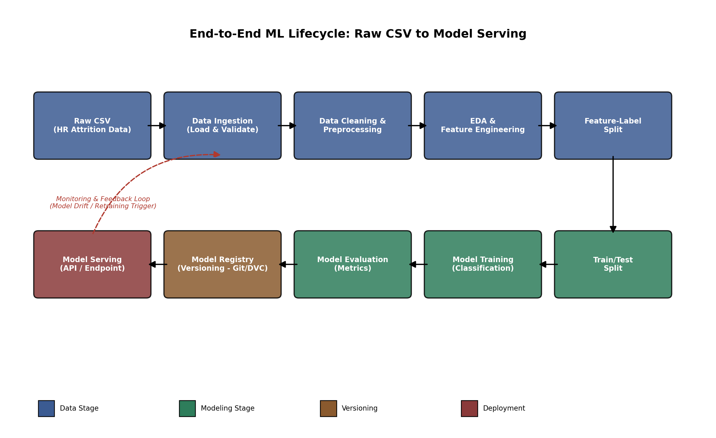

ML Lifecycle Summary
- Raw HR CSV Dataset
- Data Ingestion
- Data Cleaning & Preprocessing
- Exploratory Data Analysis (EDA)
- Feature Engineering
- Train-Test Split
- Model Training
- Model Evaluation
- Hyperparameter Tuning
- Model Selection
- Model Saving (Pickle/Joblib)
- Model Deployment
- Prediction API / Model Serving

